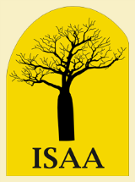
Independent Scholars Association of Australia
NSW Chapter
Annual Seminar
in conjunction with State Library of NSW
Visions of Sydney
The 1788 arrival of Governor Phillip at Farm Cove with the 11 ships of the First Fleet saw the displacement of the peoples of the Eora Nation and the establishment of the British penal colony that would become Sydney Town and, eventually, the city of Sydney. From a Georgian town to a global city, what visions have guided and directed the shapes and places of Sydney, its architecture, its landscape, its institutions?
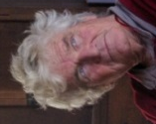
Join this Seminar to explore Visions of Sydney – past, present and future.
Keynote Address:
Sydney: Some unseen possible connections, Professor Richard Leplastrier, Professor of Architecture and Built Environment, University of Newcastle

Seminar Papers:

Dark Harbour: the literary shaping of a city, Dr Delia Falconer, Senior Lecturer, University of Technology
Courage, Common Sense and Community: Jane Jose, Chief Executive Officer, Sydney Community Foundation
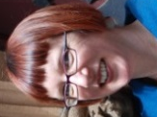
Shaping Public Sydney: 175 years of Sydney City Council, Dr Lisa Murray, Historian, City of Sydney
Date: Saturday 22 July 2017
Time: 12.45 for 1.00-4.30pm
Venue: Metcalfe Auditorium, State Library of NSW
Cost (including afternoon tea): $15 ISAA Members & Friends of Library, $20 General Public
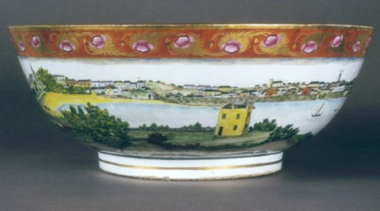
Bookings: isaansw@gmail.com

[Chinese export ware punchbowl featuring a scene of Sydney Cove before 1820]
State Library of New South Wales Collection Item
Call Number: SAFE/XR10
http://www.sl.nsw.gov.au/collection-items/chinese-export-ware-punchbowl-featuring-scene-sydney-cove-1820-1

